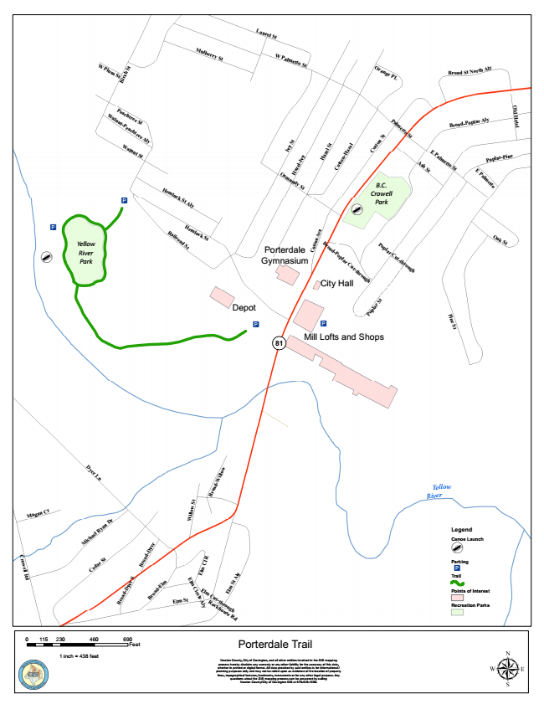
agan Ct
C r o w e l l R d
E
0 230 460 690 115
Feet
M
Laurel St
M
ulberry
St
W
W
P
lu
m
S
t
t
H
E
Palm
etto
St
O
ra
n
g
e
P
L
Broad St North Aly
P
ea
c
h
tree
S
t
W
a
ln
u
t
S
t
l
C
E
P
a
lm
e t
t
o
H
em
lo
c
k
S
t
P
o
p
la
r
C
u
t-t
h
r
o
u
g
h
P i n e S t
M
B i r c h
S
z e
O
W
a
ln
u
t-P
e
a
c
h
tr
e
e
A
ly
l d H o t e l
E
P
a
lm
e
t
to
S
t
R
o
c
k
h
o
u
se
R
d
P
a
lm
e
t
to
S
t
E
lm
C
u
t-th
r
o
u
g
h
Broad-Poplar Aly
B
t
H
em
lo
c
k
S
t
A
ly
I v
y
S
Poplar-Pine
B
I v
y
A
s
h
S t
B
O
s
m
u
n
d
y a z
e
S l -
t
H
a z e l
S t
o t t o
n - H
a
C
o t t
o
n
S t
B.C. Crowell Park
Yellow River
IA
[d
IA
[d
Park
R
a
ilr
o
a
d
S
t
Porterdale
o t t o n
A v e
B
r
o
a
d
-P
o
p
la
r
C
u
t
-t
h
r
o
u
g
h
O
a
k
S
t C Gymnasium
City Hall
Depot
P
o
p
la
r
S t
IA IA
¬« 81
Mill Lofts and Shops
D
y
e
r
L
n
r o a
d - W i l l o w
t
Yellow River
ic
h
a
e l
R
y
a
n
D
r
W i l l o w S
r
Legend
d - D
y e
Canoe [d
Launch
C
e
d
a
r
S
t
r o
a
m
C I R
Parking
IA
B
d - D
y e r
S
l
r
o
a
d -
E
lm
E l m
C i r
c l e
A l y
l m
S t
A
ly
o a
Trail
Points of Interest
r
Elm St
Recreation Parks
Porterdale Trail
1 inch = 438 feet
Newton County, City of Covington, and all other entities involved in the GIS mapping process hereby disclaim any warranty or any other liability for the accuracy of this data, whether in printed or digital format. All data provided by said entities is for informational / planning purposes only and may not be relied upon as evidence of the location of property lines, topographical features, landmarks, monuments or for any other legal purpose. Any questions about the GIS mapping process can be answered by calling Newton County/City of Covington GIS at 678-625-1650.
μ

